Comments | dates | Method | samples
No rains since spring May 2021 | 18/11/2022  Before storms | Composite around a point. | Soil samples
Impact of first rain | 25/12/2022  Before storms | Composite around a point. | Soil samples
Background concentrations of pipe outlet and stream | 12/1/2022  Before storms | Grab samples | P1, S0
Overland flow was collected by RCU.  PWF14 and PWF8 stand for surrogate samples collected from ponding water; the bottle was lost with RCU, or no overland flow filled the jar, respectively. Regular samples 2WF8 and 2Wf14 were collected in the second storm.  In ditches where we did not want to miss the stormwater or water spread to be דhallow surface flow, we also installed RCU. | In-storms samples:  16/1/2022  10:30-14:30;  and  27/1/2022  9:00-14:00 | RCU  Grab samples  RCU, Grab sample  Grab sample  Grab sample | Overland flow: PWF14, PWF8, EF1, EF3, EF4 (2WF15)*  Secondary ditch: EF2, EF5, WF10, WF16 (2WF12, 2WF17)*  Primary ditch: EF6, E7 (EF18)*  Manhole: M1 (In second storm M3 was sampled two days before campaign on 25/1/2022)*  Stream: S1 (S2)*  *Samples appearing in parentheses were added in the second storm. They were collected in addition to resampling the same locations from the first storm, and the prefix '2' was added to all 2nd storm runoff samples.
M3 is included in the second storm, two days before the campaign. M2 was samples a week after the second storm from the West field | After storms  3/2/2022 | Grab sample  Grab sample | Manholes: M2, M3  Stream: S3
Storm started after first sample was collected on the 23 at the evening. This one represents the impact of first storm. | After storms  23/1/2022-3/2/2022, every two or three days: Jan: 23,25, 27*,30 Feb:1,3.  *Only third sample (3WPzSh, 3WPzD, 3EPzSh, and 3EPzD are In 2nd storm) | Bailor | GW: Shallow and deep piezometers (Sh,D) in East and West (E,W) fields (WPzSh, WPzD, EPzSh, EPzD), totally 4 piezometers.  Samples were marked 1-6 due to sampling days. Total: 24 (6 × 4).
Enable the temporal change in subsurface water during storms. This storm, occurring late in winter, was the first to enable unsubmerged pipe sampling. | In late storm  22-27/2/2022 | Grab sample | Pipe after late storm. Samples: Before storm: P4, P5, P6. In the storm: p7, P8. After the storm: P9

Sampling methodology
Samples were collected form runoff, subsurface and groundwater. And will be described separately. While we wanted explore the first storm impact expresses in runoff, groundwater and subsurface explored also temporal changes after the storm not discussed here.

Runoff
Overland flow was expect to have very shallow surface flow, hence RCU were applied. RCU structure and installation are detailed elsewhere (Figure 1d, Rein et al., 2026). In the onion section the WF14 was submerged in ponding water and a surrogate was collected a grab sample from these water. In the first storm runoff was limited, not filling WF8 and WF9. Ponding water near WF8 were collected as a grab samples surrogate. No ponding water were near WF9. All surrogate samples were marked and a surrogate-sample exclusion sensitivity analysis based on PERMANOVA effect sizes was taken to evaluate their contribution to groups and within groups similarity. Results showed that R² differences with and without these samples is negligible ($∆$R²<0.006). Water where collected Runoff samples were collected from field ditches surrounding the field or crossing it from field overland flow. Where only part of the field or a few sections were drained into a ditch they were defined as secondary (Figure 1f). Primary ditches included water drained from secondary drainage ditches. The West field primary trench drained directly to the stream, while the East Primary ditch did not drain directly, but through the farmer road (Figure 1 c). In this ditch the water level could be shallow, hence the RCU was located. In this sample (2EF6I) it was almost full of sediments and another sample was collected from nearby a grab sample. Another sample was collected 4 hours later (F2EF6). As with the overland flow surrogates these samples were marked and their fit to results was detected. Total surrogate include only 4 samples (PWF8, I2EF6, F2EF6, P2WF14) of 63 samples. Overland flow: 1st storm:

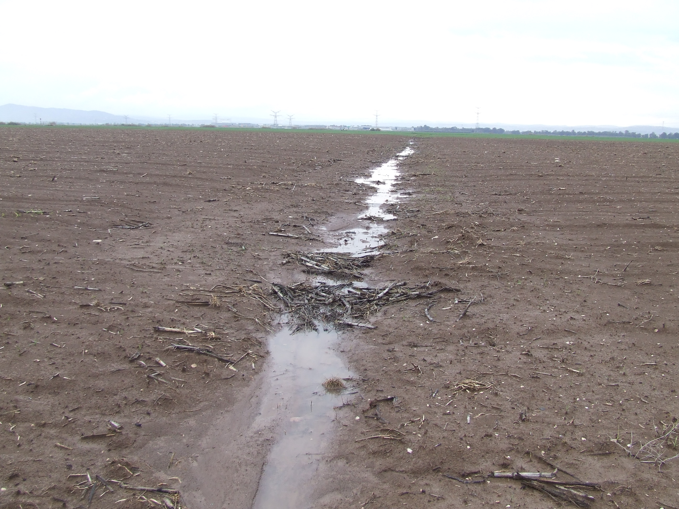
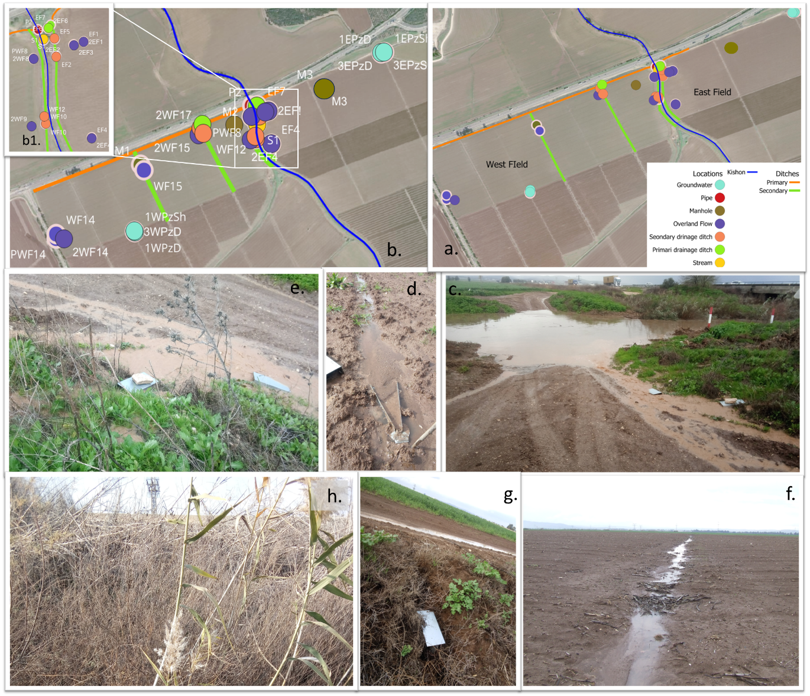
f.
a.
g.
Figure 1: Sampling array of flowpaths. groundwater- cyan,subsurface pipeoutlet- red, brown-manhole, violet- overland flow, orange-secondary ditch, light green- primary ditch, yellow- stream. a. Sampling array in field. The primary ditch is stretched along the West field and directly drains into the stream. The Primary ditch of the East field was drained through the farmer's road. b. Location of names appearing in Table 1. Zoom-in of concentrated samples near the stream banks appears in b1. c. East primary ditch drains via the farmers' road to the Kishon. d. Runoff sampling with RCU e. Ditch sampling with RCU where no regular ditch exists in a primary ditch the East field: 2EF7 (left) and 2EF6 (right). f. Secondary ditch in West field (near WF15) g. Irregular secondary drainage ditch, draining the Eastern section of Western field to the stream. Sample WF10 is shown. h. Vegetation in the West primary ditch. Grab sample was collected there (PWF18).

The analysis done to compare:

Runoff
Overland flow was expected to occur as very shallow surface flow; therefore, runoff collection units (RCUs) were used. The structure and installation of the RCUs are described elsewhere (Figure 3d, Rein et al., 2026). In the onion section, the RCU at WF14 was submerged in ponded water, and a grab sample was collected from the ponded water as a surrogate. During the first storm, runoff was insufficient to fill the RCUs at WF8 and WF9. Consequently, a grab sample was collected from ponded water near WF8, whereas no sample was collected at WF9 because no ponded water was present. The RCU enabled the collection of the overland flow disappears shortly after storm ceases, while ditches flow continuous for a while. Collecting all samples from the entire field after the storm enabled tracking also the overland flow.
Runoff samples were also collected from drainage ditches surrounding or crossing the agricultural fields. Ditches draining only part of a field or a few field sections were classified as secondary ditches (Figure 1f), whereas primary ditches received water from secondary drainage ditches. Each field has one primary ditch. The western field's primary ditch discharged directly into the stream, while the eastern field's primary ditch drained through the farm road rather than directly into the stream (Figure 1c). Because shallow water levels were anticipated in the eastern primary ditch, an RCU was installed. However, during sampling, the RCU at 2EF6I was found to be almost filled with sediment, and a nearby grab sample was collected as a surrogate. An additional grab sample was collected approximately four hours later (F2EF6).

In total, four samples collected under nonstandard conditions (PWF8, I2EF6, F2EF6, and P2WF14) were identified among the 63 samples considered in this sampling assessment. All four were flagged, and their influence on the multivariate results was evaluated using a surrogate-sample exclusion sensitivity analysis based on PERMANOVA effect sizes (Appendix SM2). The analysis compared the proportion of multivariate variation explained by flowpath classification with and without these samples. Differences in (R²) were negligible ($∆$R²< 0.006)) across the evaluated classifications, indicating that inclusion of the surrogate samples did not materially influence the overall flowpath-associated variation.
During the second sampling campaign, four additional sampling locations (WF12, WF16, WF17, and WF18) were included to improve the spatial coverage of the field drainage network.

Subsurface
Subsurface water was sampled from the pipe outlet and from manholes when the outlet was submerged. A pre-storm sample was collected to characterize baseline concentrations. During the first storm, the western manhole (M1) was sampled. During the second storm, the eastern manhole (M3) was sampled in the second storm before peak rainfall, one day before the main sampling campaign. Technical constraints prevented sampling of the western manhole (M2) during the main campaign in second storm; it was subsequently sampled a week days after the storm. Additional subsurface samples were collected from the pipe outlet once it was no longer submerged, providing observations of the subsurface response following the storm events. Except M3 (East manhole) all manholes were flooded. Subsurface drainage system

Groundwater
Groundwater sampling was conducted between 23 January and 3 February 2022, overlapping the second storm event, which began on the evening of 23 January. Samples were collected from deep (11 m) and shallow (5 m) piezometers in the East and West fields, for a total of four piezometers. Prior to sampling, three of the piezometer volumes were purged to obtain fresh groundwater representative of aquifer conditions. Water samples were collected with a bailer (Eijkelkamp LTD.). Groundwater samples collected on 27 January coincided with the second storm and are indicated in the corresponding figures. The rest of data are discussed herein only for flowpaths characteristics and time series discussed in a separate research (under review).

Nutrients
Nutrients were analyzed using water collected during the same sampling campaign as the pesticides. Because nutrient analyses required larger sample volumes than pesticide analyses, composite samples were prepared where the collected water volume was insufficient. Samples were combined based on their hydrological characteristics and sampling locations. We collected EF2 and EF5 from the same secondary ditch, and EF3 and EF4 near the edge of the eastern field, just before the secondary ditch confluences (Figure 1). All other samples provided sufficient water for individual nutrient analyses. This samples replaced the sample of ditches in east field. Nutrients were also analyzed in subsurface and groundwater samples, for which sample volume was not limiting.
Following collection, water samples were stored in an insulated container and transported to the Volcani Center laboratory at Neve Ya'ar, where they were refrigerated. Nutrient analyses were performed the following day. Samples designated for pesticide analysis were subsequently transferred to the Hebrew University laboratory in Rehovot for preservation and chemical analysis.
Soil
Soil campign aimed to characterize soil base line, before any rain in the season (last rain occurred in spring 2021), then soil resampling occurred on 25/12 after first storm. To characterize a field section we collected the very top soil (0-10 cm) and the b bottom:10-30 in four locations surrounding each point, then a composite was made for each depth. In the West field samples were collected from all section with different crops. Samples were collected on EF4, EF1, EF3, WF9, WF14, WF15.
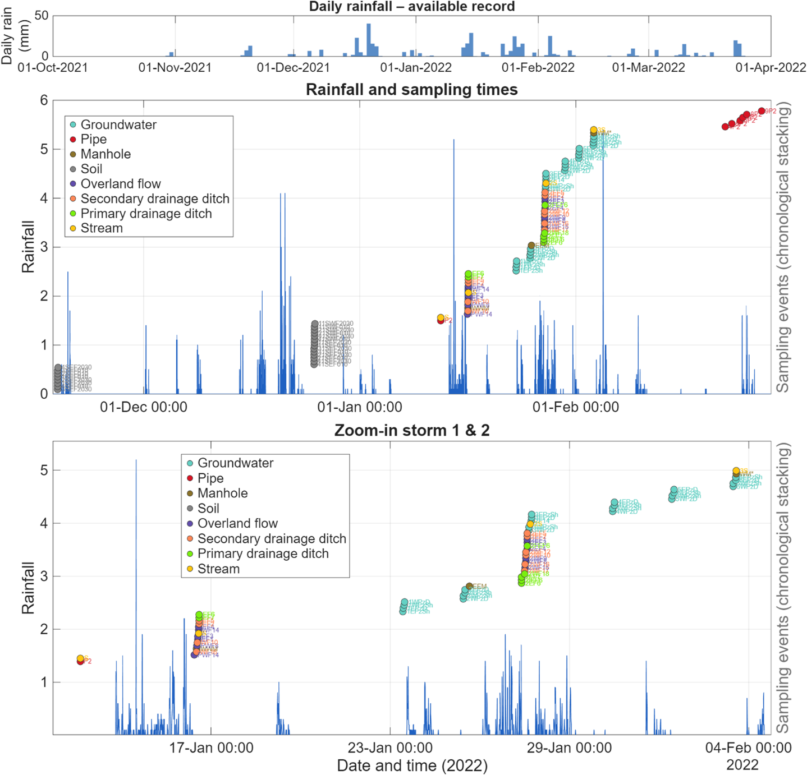
Figure 2: Rainfall dynamics and timing of soil and water sampling during the 2021–2022 rainy season. The upper panel presents daily rainfall throughout the rainy season, the middle panel shows high-resolution rainfall and sampling events, and the lower panel provides a detailed view of the two January storm events. First soil samples were collected under antecedent dry conditions, before the onset of the rainy season, with the last preceding rainfall occurring in spring 2021; another soil campaign was collected after first storm (25/12). The research main campaigns took place on 16 and 27 Jan and complementary samples where necessary were collected. Colored markers indicate sampling times across the different hydrological flowpaths, with vertically staggered positions to distinguish individual samples and improve readability. Blue lines indicate rain in mm.
-Timing of sampling V
-manholes V
-methods of other flowpaths V
-soil
-plot of rain
-nutrients composits

